Simple Origami Problem

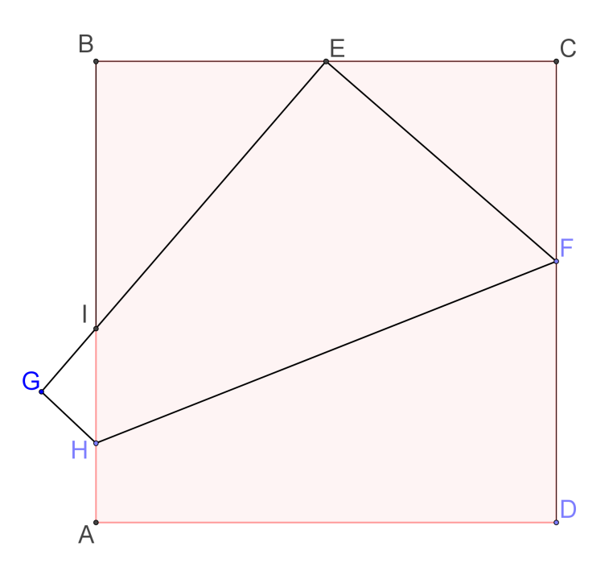
You are given a square paper of sides 24.
E is the mid-point of BC.

The piece of paper is folded so that the point D coincides with point E.

HF is the line of folding and point A goes to point G.

By considering the ΔCEF, find all line segments in the diagram.

Solution
Let $CF=x$
$CE=\frac{1}{2}×24=12$
$EF=FD=24-x$

By Pythagoras Theorem,
${\left(24-x\right)}^{2}=x^{2}+{12}^{2}$
$x^{2}-48 x+576=x^{2}+144$
$∴x=9$

$CF=x=9$
$EF=FD=24-9=15$

Note that $∠IEF=90°$
$∠BEI=90°-∠CEF=∠CFE$
Hence $∆BEI\sim ∆CFE (AAA)$

$\frac{BE}{CF}=\frac{EI}{FE}=\frac{IB}{EC}⟹\frac{12}{9}=\frac{EI}{15}=\frac{IB}{12}⟹\left\{\begin{matrix}EI=20 \\ IB=16\end{matrix}\right.$

Hence, $IA=24-IB=24-16=8$
Let $GH=HA=y, HI=8-y$
Also, $∆GHI\sim ∆BEI (AAA)$
$\frac{GH}{BE}=\frac{HI}{EI}=\frac{IG}{IB}⟹\frac{y}{12}=\frac{8-y}{20}=\frac{IG}{16}$
$\frac{y}{12}=\frac{8-y}{20}⟹y=3$

Hence, $GH=HA=3, HI=8-3=5$
Also, $\frac{3}{12}=\frac{IG}{16}⟹IG=4$

By Pythagoras Theorem,

${HF}^{2}={AD}^{2}+{\left(FD-HA\right)}^{2}$
${HF}^{2}={24}^{2}+{\left(15-3\right)}^{2}$
$HF=12 \sqrt{5}$

Yue Kwok Choy
13/7/2016

